Chapter 11
AI Based Autonomous Voice Enabled Robot with Real Time Object Detection and Collision Avoidance using Arduino
Suvarna Pawar¹, Pravin Futane², Nilesh Uke³, Sourav Patil^{4*}, Riya Shah⁵, Harshi Shah⁶, and Om Jain⁷

¹ Head of Department and Professor, Dept. of Computer Engineering, D Y Patil University, School of Engineering and Technology, Pune (M.H.), India. Email Id: pawar.suvarna@gmail.com.
² Head of Department, Dept. of Information Technology Engineering, Vishwakarma Institute of Information Technology, Pune-411048 (M.H.), India. Email Id: pravin.futane@viit.ac.in.
³ Principal, Trinity Academy of Engineering, Pune-411048 (M.H.), India. Email Id: nilesh.uke@gmail.com.
⁴ Third Year Student, Dept. of Information Technology Engineering, Vishwakarma Institute of Information Technology, Pune-411048 (M.H.), India. *Corresponding Author Email Id: sourav.22020060@viit.ac.in.
⁵ Third Year Student, Dept. of Information Technology Engineering, Vishwakarma Institute of Information Technology, Pune-411048 (M.H.), India. Email Id: riya.22020082@viit.ac.in.
⁶ Third Year Student, Dept. of Information Technology Engineering, Vishwakarma Institute of Information Technology, Pune-411048 (M.H.), India. Email Id: harshi.21911209@viit.ac.in.
⁷ Third Year Student, Dept. of Information Technology Engineering, Vishwakarma Institute of Information Technology, Pune-411048 (M.H.), India. Email Id: om.21910089@viit.ac.in.
Abstract: With a busy schedule and never-ending work meetings, we need a small helping hand for us to do a few household chores like switching on/off lights, detecting and bringing an object be it fruit or something else. Our project introduces artificial intelligence-based voice, a remotely operated robot Currently, there are a variety of methods for controlling one. Controlling it with voice commands is the most user-friendly option. It is also a well-known reality that handicapped persons suffer a variety of physical mobility challenges. In such circumstances, the robot operations are to be Controlled by human voice instructions, it may be a viable solution to the problem. Controlling the robot using the user's vocal commands and visual feeds which will be helpful to make it easier and more precise for the robot to operate Voice-controlled robots powered by artificial intelligence (AI) assist people save time and effort in their daily duties. Following the interpretation of voice instructions, a set of control data for completing a job is created. The machine can perform different movements forward, backwards, turns, start/stop and night mode operation.
Keywords: Artificial Intelligence, Voice Robot, Image Processing, Natural Language processing, Wireless Technology.
  - Introduction
Our goal is to create a robot vehicle that can be easily and effectively operated using voice instructions from a person or user[12]. Speech Controlled Automation Systems (SCAS) are another name for these systems (SCAS). The robot we built is a working prototype of the technologies detailed previously. The idea is to create a robot that can be controlled via human voice instructions. The robot will be controlled remotely using a smartphone app called Smart AI for Android. Android applications give a highly good interface for remotely automating the robot. It features a variety of functions that the robot's user may find useful.

In this concept, an android application with several features is used for the required purpose. The application and the robot can communicate more easily thanks to Bluetooth technology. The specified commands will be delivered across the channel to the bluetooth module that receives it. VCRVs are voice-controlled robotic vehicles that listen to the user's orders and respond accordingly. The system will require accent training, during which the device will learn to interpret the orders provided to it and will be incorporated into the Arduino software so that it can do its tasks correctly.

The primary goal of VCRV development is to analyse speech and respond to pre-programmed commands. Backward, forward, right, left, night mode, and halt the robot are the most fundamental commands. The car will be controlled remotely using an Android application on a smartphone. Our goal is to create a robotic automobile that employs contemporary smartphone technology in a very simple and cost-effective way, employing object recognition with the ESP32 camera module to understand and respond to the distinctions between various sorts of items. We'll also use an ultrasonic sensor to detect things and give the robot's algorithm instructions to avoid colliding with them.

Natural language processing is a new technology that allows us to use our voices to command and control objects. Wireless technology is becoming increasingly significant in today's world. Wired networks are inefficient, confusing, and difficult to comprehend. Wireless technologies have had a huge positive impact on human existence, and the rate of human advancement has greatly quickened. The voice control robot is controlled by vocal instructions delivered directly to the robot by the user. As far as we can tell, this is a wireless robot. On a smartphone that functions as a transmitter, the android app is installed. The orders are issued via the android application. The Arduino is identified via a Bluetooth connection and the Smart AI application.

A Bluetooth module is connected to the Arduino (HC-05). Arduino must be programmed in C or C++ since it is programmable. As a consequence, pairing an Android application (Smart AI) with a Bluetooth module is straightforward. The user provides the Smart AI Android App orders. Voice recognition technology is used in a number of applications to control equipment and contribute to society's modernization. The fundamental idea behind this model is to utilize an Android smartphone to communicate with a robot via Bluetooth network connectivity. This technology is used to assist people with disabilities, in addition to industrial uses such as voice-controlled working robots Every technology has its own set of benefits and drawbacks. On the other hand, Bluetooth-based voice-controlled robot systems have the upper hand. Devices can be connected up to 10 meters apart. Bluetooth also uses the 2.4GHz ISM band, which is available all across the world. Bluetooth services are available at a maximum speed of 2.8 Mbps. Fast advancement in Bluetooth-based speech recognition systems has been possible as a result of these benefits.

Currently, vehicles are operated manually, and the driver is solely accountable. Every movement, including starting and stopping, applying brakes, shifting gears, and accelerating, requires human effort. However, new technologies have arisen in recent years that might be integrated with traditional autos to create new vehicles. The introduction of gesture concepts in the current era is bringing the physical and digital worlds closer together. We prefer technology over people in all perilous situations. Originally operated by hand, these robots may now be controlled through speech and gestures. The interface between a computer and human body language may be characterized as gesture and speech recognition technology. This establishes a communication link between humans and machines. The goal of this study is to improve the security of robots while also simplifying their control systems. A smart phone is required to manage voice directions. The findings of the underlying investigations are used to complete the execution evaluation. The predicted benefits might be used in a number of settings, such as enterprises, medical clinics, and environmental laboratories. The world's most severe problem is the lack of human labor. They may maneuver around in a wheelchair on their own using this gadget by simply speaking orders through Bluetooth. All of the features are integrated into a single module to create a prototype.
  - Literature Survey
To improve the functionality of AI Robot, Licheng Jiao et al.[1]. In this paper it is specified about the types of detection models, datasets, In a nutshell, metrics and applications. According to their study, domain-specific image object detectors may be divided into two groups: one is a two-stage detector, the most common of which is Faster. One is a one-stage detector, such as YOLO or SSD, while the other is R-CNN. With the advancement of DL and the continual expansion of processing capabilities, great progress has been made in the field of generic object detection. The first CNN-based object detector, R-CNN, made several significant contributions to the area of generic object recognition. They've offered various typical object detection designs to help newcomers get started in this field. To detect objects, deep learning models such as CNN, RNN, and LSTM can be employed. Other computer vision libraries, such as OpenCV, are also free to use. Furthermore, the Internet of Things is built on massive data. The performance of deep learning is reliant on a big amount of data, which functions as rocket fuel.

Humayun Rashid et al.[2] stated that the robot's motions can be controlled by sending vocal instructions to the microcontroller, because the design system incorporates a microcontroller connected to the smart phone through Bluetooth module for the transmission and receiving of voice commands, these are subsequently converted to text using an android smartphone application. The robot's answers, which are supplied in response to the vocal orders, follow the data. To produce a precise movement in a certain direction, voice instructions are employed. The robot's speaking technology is based on an SD card with a pre-recorded human voice. This audio file is then used by the robot's speaking system. After receiving each of the orders from the device, the robot will pronounce the phrases and operate in accordance with the instructions.

In this paper, by Soniya Zope et al.[3] stated that according to the project's description, voice commands, as well as manual remote operation control, are offered for operating robotic equipment or vehicles. The ATMEGA32 microcontroller and bluetooth device are used to integrate the control unit interface and detect signals delivered by the android app. The serial data received from the bluetooth module connected to the ATMEGA32 is sent via the Android app. The study describes how to use a Wi-Fi module and an Android app on a smartphone to drive robot automobiles.

In the given paper, by V. Shivaraju et al.[4] We'll show you how to utilize an Android cellphone and a Wi-Fi module to drive a robot-controlled car. We'll also show how we can control the appliances without an Android phone by sending regular text messages to the user. The advantage of using a robot-controlled vehicle is that it may be used for a range of tasks. This idea may easily be expanded to include a spy camera that can send movies to the user through Wi-Fi. For the project, solar cells would be employed instead of the typical lithium-ion battery. This robot car might potentially be used to move items from one place to another. This project will get better Wi-Fi connectivity, allowing people to do more and to communicate across vast distances.

Lokireddy Sai Siddhardha Reddy et al.[5] stated in the paper, The basic goal of a robotic vehicle is to assess voice commands and do tasks without the need for human intervention. The user's voice is used to operate the robot. To run the robot utilizing user voice input instructions, an android-developed programme that interacts using Bluetooth modules is necessary. As a result, this book primarily targets physically challenged individuals. As a consequence, users will be able to drive their self-driving car with more safety and security in the future, as automated braking and slowing capabilities will safeguard them against unexpected hit-and-run attempts. When it comes to hardware, a robotic vehicle's motors will be controlled by a modified Arduino. When the automobile senses any unexpected or abrupt impediment, ultrasonic sensors will cooperate with the Arduino board to help in autonomous braking.

Santoshachandra Rao Karanam et al.[6] given in the paper, the way Image processing is vital in sectors such as medical imaging, medical image analysis and processing, web mining, and so on are all examples of image mining. In the healthcare business, CBMIR (Content-Based Medical Image Retrieval) technologies are critical. The fundamental purpose of medical database graphics is to make searching and retrieving medical data easier. The following article demonstrates how to apply deep learning algorithms for image segmentation in photo processing. This article discusses the many deep learning applications for medical imaging and image mining. It also demonstrates how to use content-based image retrieval to find problems in medical photographs.

M. Naveen Kumar et al.[7] stated in paper, the purpose of image processing is to help a computer understand the information in a picture. OpenCV is a computer library that specializes in image processing. In computer vision applications, it is commonly used as the de facto API. Image processing software can assist us in solving a wide range of real-time issues. This page offers step-by-step instructions as well as real-world examples of OpenCV-based real-time image processing applications.

Mingyuan Xin et al.[8] mentioned in their paper based on an evaluation of the error backpropagation approach, we suggest a unique depth neural network training criterion for maximum interval minimal classification error. To improve outcomes, the cross entropy and M3 CE are examined and integrated at the same time. Finally, we put our proposed M3 CE-CEc to the test on MNIST and CIFAR-10, two deep learning benchmark datasets. The findings demonstrate that M3 CE can increase cross-entropy and can be used in conjunction with the cross-entropy criterion. M3 CE-CEc performed brilliantly in both datasets.

Prof. P Y Kumbhar et al.[9] stated to use the Haar Classifier on the Raspberry Pi BCM2835 CPU processor, to accomplish real-time Face detection and tracking of the head postures position from high-quality video, the system uses a mix of SoC and GPU-based architecture. The libraries SimpleCV and OpenCV are used for face detection and tracking the location of head positions. The above-mentioned hardware, together with the SimpleCV and OpenCV framework libraries, were utilized to provide results at 30 frames per second at 1080p resolutions for improved precision and speed in face identification and head tracking.

Wenhuan Wu et al.[10] mentioned that, in an autonomous face recognition system, face detection is crucial. This paper explains how to use a cascade of Adaboost classifiers to recognise faces and how to set up OpenCV in MCVS. With the aid of OpenCV, we were able to detect faces. A thorough examination of the face detection results is also offered. Experiments show that the method used in this article has a high accuracy rate and excellent real-time performance.
11.3 Proposed System Design and Methodology

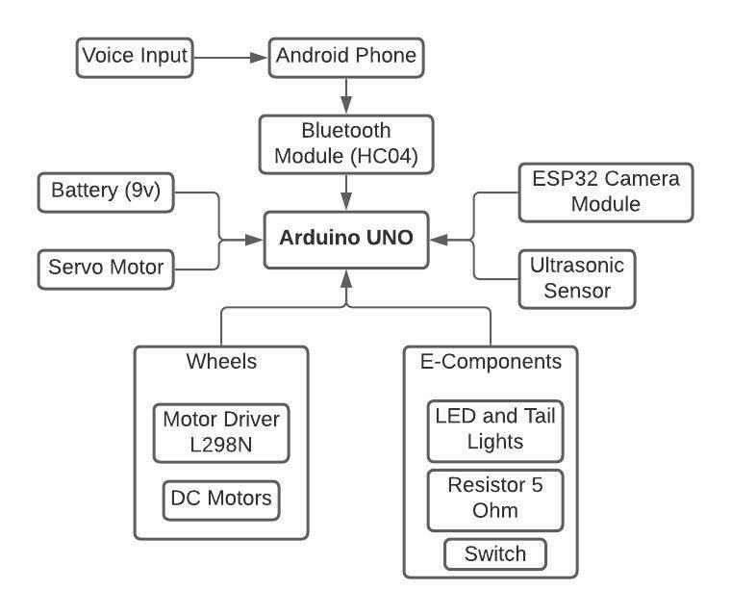
Fig.1: Block Diagram of Robot

The flow to architecture starts with giving input to the robot with the help of android phone, afterwards user has to connect their device with the Bluetooth Module, later on the Arduino is connected to with the sensors and devices like Camera Module, Servo Motor, Ultrasonic Sensor and Battery, then various other components are connected with the robot to make it more futurized and make all operations flexibly and smoothly like Motor Driver, DC Motors, LED’s, Resistors and Switch. This was all about the Architecture Diagram. The robot functions in a proper way to give better functional requirements to the user of the robot respectively as per their voice commands.

Speech is the fastest mode of communication, according to research, and it has a wide range of uses, including in-car systems, medical attention, Military personnel, Educate yourself, Intelligent structures. The current approach focuses solely on controlling the robot, which is capable of comprehending orders and carrying them out. The robotic car responds to commands sent through an Android device, which is why Arduino is included in the system. Any Android-based smartphone can be used as the controlling device. The transmitter makes use of an Android application that is necessary for data transmission. These commands are read by the receiving end, which then interprets them to operate the robotic vehicle. The android device provides orders to the car to travel forward, backward, right, and left. Arduino uses the commands to control the motors, which let the car move in four directions. Serial communication data is transmitted between the android smartphone and the receiver. The Arduino software is intended to control the motor through a motor driver circuit in response to orders provided from an Android device.

Flow Chart:
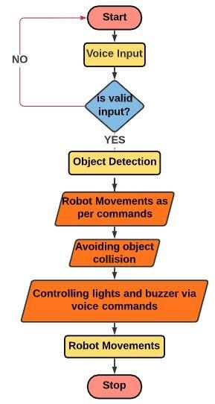
Fig.2: Project Flow Chart of Robot
User needs to give voice input, if the input is valid the signal process further and detects objects then the robot moves as per command and avoids object collision. It also controls light and buzzer as per commands of the user and at last stops. Here the user has to firstly switch on the robotic car then the bluetooth module will start by blinking the red light present inside it and afterwards the user will connect the bluetooth module with the android application with HC05 bluetooth connection where the bluetooth connection having a range of 10 meters, then the user will click on the voice option present in the android application and will give voice commands which are already feeded into the arduino UNO board once the commands of user matches with the command present in the arduino code the operation will be performed and once the user will use commands as “Go Ahead” then the UR sensor will check the object in forward direction if it detects any inside 1 meter range then it will not move and play the buzzer twice and turn on the red parking lights inside the robot otherwise move in forward direction upto 8 seconds asper delay given into the arduino code, same as for “Left” command the robot will check for object in left direction and will perform accordingly, same will be for “Right” and “Go Back” Command and lastly the “Night Mode” command, this command will turn on the white lights present inside the robot to get clear vision for the camera to detect objects and display the names when used in night time.

This was the process flow of the autonomous vehicle with all functionality and processes carried out to perform various operations by the user of the robot.

System Requirements:

The following components make up the System Design: -

- Arduino UNO Board
b. Motor Driver L298N
c. HC05 Bluetooth Module
d. Ultrasonic Sensor
e. BO Motors
f. Connecting Wires
g. ESP32 Camera Module
h. Power Supply
i. Wheels
j. Servo Motor
k. USB to TTL Module
a. Arduino UNO:
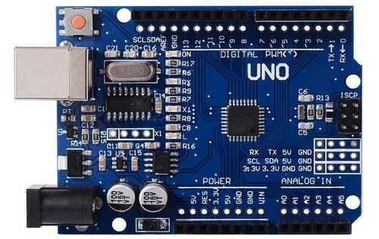

Fig.3: Board for Arduino UNO R3 [31]

The ATmega328P CPU is used in the Arduino Uno [18], a microcontroller. On this board, you'll find 14 digital I/O pins, six analogue inputs, a 16 MHz ceramic resonator, a USB port, a power connection, an ICSP header, and a reset button. Everything you'll need to get started is included with the Arduino Board.

- L298N Motor Driver:
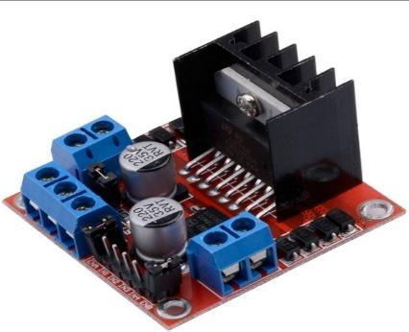

Fig.4: Motor Driver L298N [32]

The L298N is a dual-channel H-Bridge motor driver that can drive two DC motors seamlessly.

- Bluetooth Module HC05:
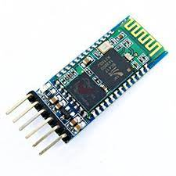
Fig.5: Bluetooth Module (HC05) [33]

The HC-05 is a Bluetooth module with a 2.4GHz frequency that enables wireless communication between two devices. The HC-05 Bluetooth Module is a straightforward Bluetooth SPP (Serial Port Protocol) module that lets you construct a transparent wireless serial link. It uses serial communication to connect to a controller or a computer, making it simple to set up.

- Ultrasonic Sensor:
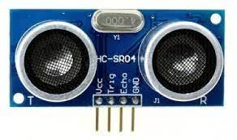

Fig.6: Ultrasonic Sensor HC-SR04 [34]

A device that creates ultrasonic sound waves to count the distance to a target item, converts the reflected sound into an electrical signal, and responds is known as an ultrasonic sensor. To calculate the distance between the sensor and the object, the sensor measures the time between the transmitter's sound emission and its contact with the receiver.

- BO Motors:

The DC/BO Motor (Battery Operated) is a tiny DC geared motor with high torque and rpm at low voltages. This motor can spin at roughly 200 rpm in both clockwise and anti-clockwise directions when fueled by a single Li-Ion cell.

- Connecting Wires:

Jumper wires are basic cables having connector pins on both ends that may be used to connect two points without the use of solder. They are available in male-to-male, male-to-female, and female-to-female combinations. Individual jump wires are joined by fitting their "end connectors" into slots on a breadboard, the header connection of a circuit board, or a piece of test equipment. There are solid tips, crocodile clips, banana connections, RF connectors, and more connectors to choose from.

- ESP32 Camera Module:
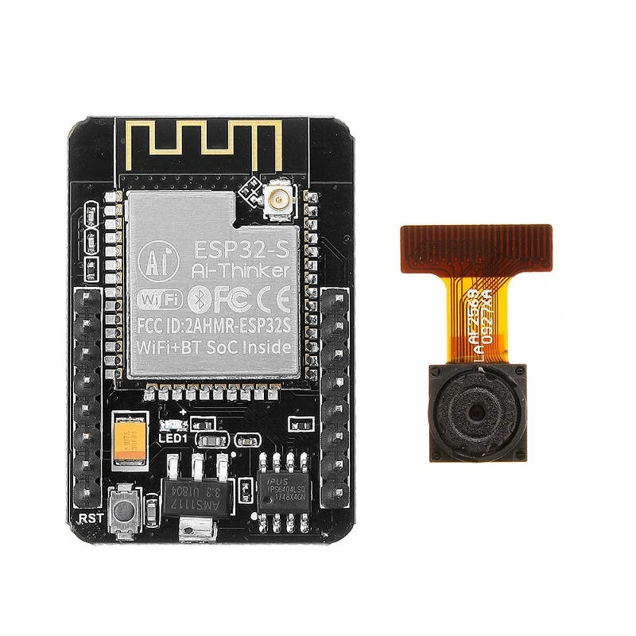

Fig.7: ESP32 Camera Module [35]

The ESP32-CAM module is a full-featured microcontroller that includes video camera streaming and a microSD card reader.

- Power Supply:

Used to supply power to the Arduino so that it may do activities. Batteries are made up of one or more cells, each of which uses chemical processes to create an electron flow in a circuit. The three basic components of all batteries are an anode (the '-' side), a cathode (the '+' side), and some type of electrolyte (a substance that chemically reacts with the anode and cathode).

- Wheels:

Used to effortlessly spin or transfer the robot from one location to another. With a round black grip to keep the robot steady on any surface.

- Servo Motor:
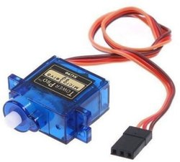

Fig.8: Servo Motor SG90 [36]

A servomotor is a rotary or linear actuator that has the ability to precisely control angular or linear position, velocity, and acceleration. It consists of a suitable motor and a position feedback sensor.

- USB to TTL Module:
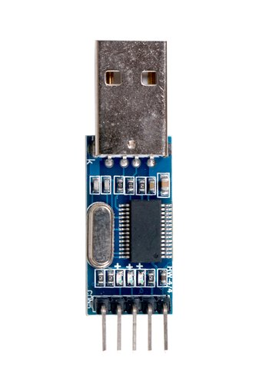

Fig.9: USB to TTL Module [37]
Prototyping requires USB to TTL module converters because they allow direct interface with the target device. This module connects to your target device by four cords that go into your computer's USB port. For simple serial connections with non-USB devices, the PL2303HX USB to TTL converter module is required.

Project Methodology:

Human-robot interaction is one of the most important factors that can assist spread the usage of robots in everyday life. Guidance systems are one of the potential uses for guiding visitors or tourists (e.g., at museums, tourist navigation in cities, etc.). We used a simple way to use human speech to operate a robotic car. To begin, all human directions are converted to text using Google's speech to text converter, which is then compared to the code presently being fed into the arduino board. Everything we need is present within the Android app we're using. The textual format command is subsequently sent to the robot's Bluetooth module. The purpose of this research is to provide a streamlined robot hardware architecture with powerful computing platforms so that robot designers may focus on research and testing rather than Bluetooth communication infrastructure. Because students may build their own robots for a low cost and use them as a platform for experimentation in a range of subjects.

    - Voice Controlled System:
The task of speech recognition is to convert speech to digital data, but the task of voice recognition is to identify the speaker. Voice recognition works by assessing how different people's voices sound. Everyone has a unique speech pattern influenced by physiology (mouth and throat size and shape) as well as habits (voice pitch, speaking style, accent, and so on).

Voice recognition software differs from speech recognition software in some ways. The most typical applications of voice recognition technology are to verify a speaker's identity or to determine the identity of an unknown speaker. Speaker verification and speaker identification are the two types of voice recognition.

- Algorithm:

In their 2001 paper "Rapid Object Detection with a Boosted Cascade of Simple Features," Paul Viola and Michael Jones proposed an effective object identification strategy based on Haar feature-based cascade classifiers. It's a machine-learning method that involves learning a cascade function from a large number of positive and negative images. It's then used to locate items in other photographs.

In this room, we'll be working on facial recognition. The approach requires a large number of positive (face-containing) and negative photographs to train the classifier (images without faces). After that, we'll have to extract attributes from it. The haar properties illustrated in the image below are used to do this. They resemble our convolutional kernel in appearance. To get a single value for each feature, subtract the total number of pixels in the white and black rectangles from the total number of pixels in the white and black rectangles.

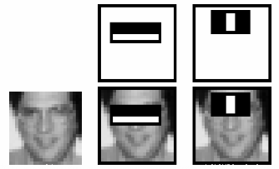

Fig.10: Haar Cascade Working with Face Detection [38]
11.4 Robot Implementation
- Libraries Used:
A reservoir of pre-trained Haar cascades is kept in the OpenCV library. The majority of Haar cascades are employed for one of the following purposes:
- Face detection
- Eye detection
- Mouth detection
- Full/partial body detection
- Object Detection
- Adafruit Motor Shield library
- Servo Motor Library
b. Android Application Design:

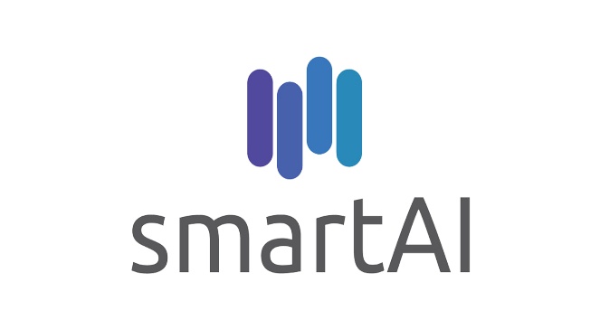

Fig.11: Android App Logo
Logo of the Android Application Smart AI, which is developed in Android Studio to control the AI based autonomous vehicle through voice commands by App and for surveillance through camera module.
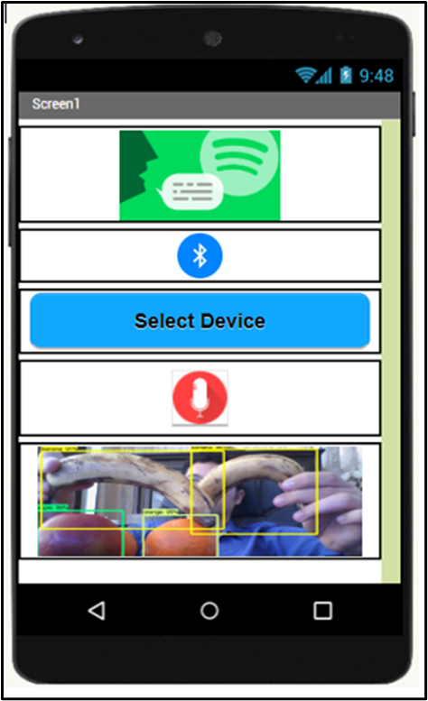
Fig.12: Android Application Design ESP32 Cam detecting the objects as per shape, color and size.
c. Development Software:

Arduino IDE is used to develop the program for Arduino UNO Board to control all things and perform accordingly as per the given input.
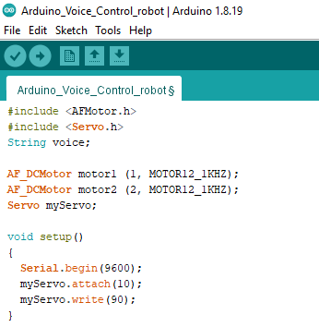
Fig.13: Arduino IDE for Development of Hardware Code
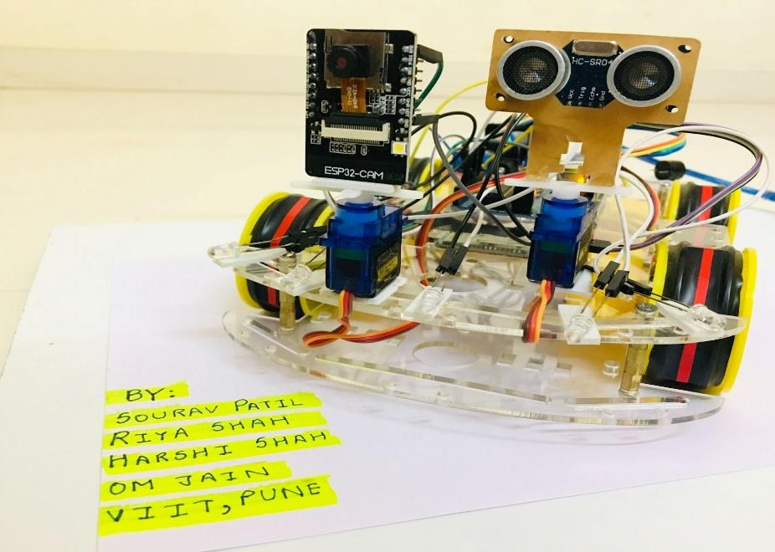
d. Hardware Implementation:
Fig.14: Implemented Hardware with UR Sensor and Camera Module for Object Detection and Collision Avoidance.
- The above diagram works as follows:

- The Bluetooth Button is used to search for available bluetooth connections and connect to Bluetooth Module HC-04.

2. The Mic button is used to take voice instructions and perform robot operations based on those inputs by translating the commands to text using Google Voice Assistant's Speech-to-Text API [7], with the robot doing the actions as programmed in the arduino uno board.

3. The background is the video streaming by the robot in front of it detecting and telling the difference between various objects using the ESP32 camera module [8].

4. The App can also detect other objects like, laptop, keyboard, human, watch, mouse, and many more and display it on the app screen by streaming through the camera module.
  - Results and Discussion
When the robot receives a spoken command or instruction from the user, it begins to move.

- The user's commands can be used in a variety of ways. "Go Ahead", "Back", "Left", "Right", “Stop” and “Night Mode”.

2. The robot follows the user's orders/commands and performs the tasks assigned to it.

3. When an obstruction appears in front of the robot at a distance of less than 1 meter, the Ultrasonic sensor detects the impediment and the robot promptly stops by sounding the buzzer twice.

4. The robot will remain in this mode until the user issues the next vocal instruction.

5. The Robot operates on Bluetooth Technology with a range of 10 meters which enables it to be controlled from long distances as well.
6. The robot also detects the objects around it and displays the name of the component in the user’s android application Smart AI through video surveillance via ESP32 Camera module.

The robot is given the following vocal commands:

TABLE 1

INPUT (User Voice Commands) | OUTPUT (Execution of commands by robot)
“Go Ahead” | Robot goes in Forward Direction
“Back” | Robot executes reverse and go back
“Left” | The Robot Moves to the Left
“Right” | The Robot Rotates to the Right
“Stop” | Terminates all previous commands then turn red light and buzzer on and stops
“Night Mode” or “Night Mode Off” | Starts the Front White Lights as Headlights

Case1: When the distance between you and the barrier is more than or equal to one meter, you can utilize voice instructions such as "Forward," "Backward," "Left," "Right," "Stop," and so on.

Case2: You have a few voice command choices when the distance between you and the barrier is less than 1 meter. "Backward," "Left," "Right," and "Stop" are some of the terms used.
11.6 Conclusion and Discussion
This research outlines the prototype and design for an android robot; nevertheless, much more work and research is needed in the future to turn the created robot into a fully working consumer product. The built Robot may move in any direction based on a verbal command received from the user using an Android phone and Bluetooth. The robot can be moved forward, backward, left, and right via voice instructions. Thanks to an ultrasonic sensor, the Robot can also move completely independently without striking any obstacles.

Using Bluetooth technology, the suggested solution shows how an Android smartphone may be used as a remote controller for robots and other embedded equipment. The suggested technique also demonstrates how image processing may be used to assist any disabled person with little tasks, as well as guide and recognize items.
11.7 Future Scope
The Benefits of Voice Control Human intervention is no longer required, and operations may be completed faster. The robot is capable of understanding natural language commands. A collection of control data for tasks like object recognition and collision avoidance is developed when the spoken orders are interpreted. Through robotics, we develop strategies to outsource human functions to machines, and we may assist or even replace humans in doing jobs. Although now limited to a few vocal commands, we want to improve this in the future using Machine Learning and Natural Language Processing, and we will also use the Lorawan Protocol in our robot to allow it to function in locations with extremely low bandwidth. We may be able to use this technology for military objectives by connecting appropriate sensors because the robot carries a camera module that will show live streaming. We can assign IP addresses to this system in the future so that more than one device can be linked, which will help with live broadcasting of the enemies' suspicious actions and also by training it with different images to understand the difference between the Indian Army and other unregistered people.
Acknowledgement
We would like to express our heartfelt gratitude and appreciation to our guide, Suvarna Pawar ma'am, for providing us with invaluable guidance, support, and encouragement on a daily basis, which inspired us to work even harder to complete the project. We are also grateful for her efforts that she put in on us to make this project happen.
References
[1] Licheng Jiao, Fan Zhang, Fang Liu, Shuyuan Yang, Lingling Li, Zhixi Feng, Rong Qu, “A Survey of Deep Learning-Based Object Detection”. ISSN: 2169-3536, Volume 7, 2019.

[2] Humayun Rashid, Iftekhar Uddin Ahmed, Sayed Bin Osman, Qader Newaz, Md. Rasheduzzaman, S M Taslim Reza, “Design and Implementation of a Voice Controlled Robot with Human Interaction Ability”. ISBN: 978-984-34-2030-5, Paper ID: 65, 26-27 January, 2017.

[3] Soniya Zope, Preeti Muluk, Rupali Mohite, Aishwarya Lanke, Megha Bamankar, “Voice Control Robot Using Android Application”. ISSN: 2454-1362, Volume-3, Issue-2, 2017.

[4] V. Shivaraju, V. Karthik Kumar, “Robot Controlled Car using Wi-Fi Module”. ISSN: 2319-8885, Volume-06, Issue: 04, February-2017, Pages: 0759-0762.

[5] Lokireddy Sai Siddhardha Reddy, M Sumanth, Maram Venkata Nagasai Teja Bavigadda Purushotham Naidu, Shalini Tiwari, “Voice Based Robotic Vehicle with Obstacle Avoidance”. ISSN No. 0976-5697, Volume 11, Special Issue I, May 2020.

[6] Santosh Chandra Rao Karanam, Y. Srinivas, M. Vamshi Krishna, “Study on image processing using deep learning techniques''. ISSN No. 2214-7853, October 2020.

[7] M. Naveen Kumar, A. Vadivel, “OpenCV for Computer Vision Applications”. March 20, 2015.

[8] Mingyuan Xin, Yong Wang, “Research on image classification model based on deep convolutional neural networks”. 11 February 2019.

[9] P Y Kumbhar, Mohammad Attaullah, Shubham Dhere, Shivkumar Hipparagi, “Real Time Face Detection and Tracking Using OpenCV”. E-ISSN: 2349-7610, VOLUME-4, ISSUE-4, APR-2017.

[10]Dr. Wenhuan Wu, Yingjun Zhao, Yongfei Che, “Research and Implementation of Face Detection Based on OpenCV”. Vols. 971-973 (2014) pp 1710-1713, 2014-06-25.

[11]Aditya Chaudhry, Manas Batra, Prakhar Gupta, Sahil Lamba, Suyash Gupta, “Arduino Based Voice Controlled Robot”. ISBN: 978-1-7281-4826-7/19/$31.00.

[12]Shivangi Nagdewani, Ashika Jain, ”A Review On Methods For Speech-To-Text And Text-To-Speech Conversion”. ISSN: 2395-0072, Volume: 07, Issue: 05, May 2020.

[13]Dr.G.Rohini, Monikandan. R, Ramesh. R, Vignesh. K, “Spy Bot for Monitoring Human Activities In Restricted Area During Covid19 Lockdown”. ISSN- 2394-5125, VOL 7, ISSUE 05, 2020.

[14]Dr. C. Shyamala, S.RahmathNisha, B. Aswini, V. Bakkiya Sri, S. Dheyvanai, ”Online Voice Based Multipurpose Surveillance Robot for Defense Using Artificial Intelligence” Vol.12 No.7(2021), 784-794.

[15]Dinesh P Mital, Goh Wee Leng, “A Voice-Activated Robot with Artificial Intelligence”. ISBN:0-87942-688-8, CH2976-9/91/0904.

[16]Yasir Ali Memon, Imaaduddin Motan, Muhammad Ali Akbar, “Speech Recognition System For A Voice Controlled Robot With Real Time Obstacle Detection And Avoidance”. Volume-4, Issue-9, Sep.-2016.

[17]P. Ramya, U. Rehanabegum, P. Manimegalai, Dr. S. Manikandan, “Voice Controlled Robot Writer for Physically Challenged”. Volume 1, Issue - 3, Dec 2017.

[18]Sumeet Sachdeva, Joel Macwana, Chintan Patela, Nishant Doshia, “Voice-Controlled Autonomous Vehicle Using IoT''. 21 November 2019.

[19]Aditya Chaudhry, Manas Batra, Prakhar Gupta, Sahil Lamba, Suyash Gupta, “Arduino Based Voice Controlled Robot”. 1 October 2019.

[20]Vikash Sharma, Vrutik Parvadiya, Rohan Naik, “Automate Voice Controlled Robot Using Raspberry Pi 3b+”. Vol 8, No 1 (2021).

[21]Mamatha K R , Shalini Ragothaman ,Krithika Raj D , Susmi Zacharia , Anusha N, “Implementation Of Voice Controlled Robot Using Android Application”. ISSN: 2454-5031.

[22]K. Manu Subhash, Dr. M. C. Chinnaaiah, I.S.B.N. Varma, G. Abhiram Varma, “Robot control through voice recognition using LabVIEW”. ISSN: 2454-132X, Volume 6, Issue 3.

[23]N. U. Alka, A. A. Salihu, Y. S. Haruna and I. A. Dalyop, “A Voice Controlled Pick and Place Robotic Arm Vehicle Using Android Application”. e-ISSN: 2320-0847, p-ISSN: 2320-0936, Volume-6, Issue-7, pp-207-215.

[24]Adarsh Singh, Omkar Naik, Amit Ghadi, Ahmed Khalil, “Voice Control Robotic Arm as A Physical Assistant For Paralyzed Person”. ISSN: 2349-5162, Volume 8, Issue 12, December 2021.

[25]Lochan Basyal, Sandeep Kaushal, Gurjeet Singh, “Voice Recognition Robot with Real Time Surveillance and Automation”. ISSN: 2320-2882, Volume 6, Issue 1, March 2018.

[26]How2electronics, “ESP32 CAM Based Object Detection & Identification with OpenCV”

[27]Last minute engineers, “Interface L298N DC Motor Driver Module with Arduino”.

[28]Rao, Kschandra & Srinivas, Y & Krishna, M. (2020). Study on image processing using deep learning techniques. Materials Today: Proceedings. 10.1016/j.matpr.2020.09.536.

[29]Mahamkali, Naveenkumar & Ayyasamy, Vadivel. (2015). OpenCV for Computer Vision Applications.

[30]Xin, M., Wang, Y. Research on image classification model based on deep convolutional neural network. J Image Video Proc. 2019, 40 (2019).

[31]https://www.indiamart.com/proddetail/arduino-uno-ch340-board-19651448730.html

[32]https://kuongshun.com/products/l298n-stepper-motor-driver-board-red

[33]https://www.electronicwings.com/sensors-modules/bluetooth-module-hc-05-

[34]https://www.indiamart.com/proddetail/hc-sr04-ultrasonic-sensor-18101779448.html

[35]https://robu.in/product/ai-thinker-esp32-cam-development-board-wifibluetooth-with-ov2640-camera-module/

[36]https://www.indiamart.com/proddetail/sg-90-tower-pro-micro-servo-motor-20797318397.html

[37]https://www.indiamart.com/proddetail/pl2303-usb-to-rs232-ttl-converter-adapter-module-11086683012.html

[38]https://docs.opencv.org/3.4/db/d28/tutorial_cascade_classifier.html

